**Name-Anubhav Singh**

**Section -D2203**

**Roll no -30**

**Course code-CAP482**

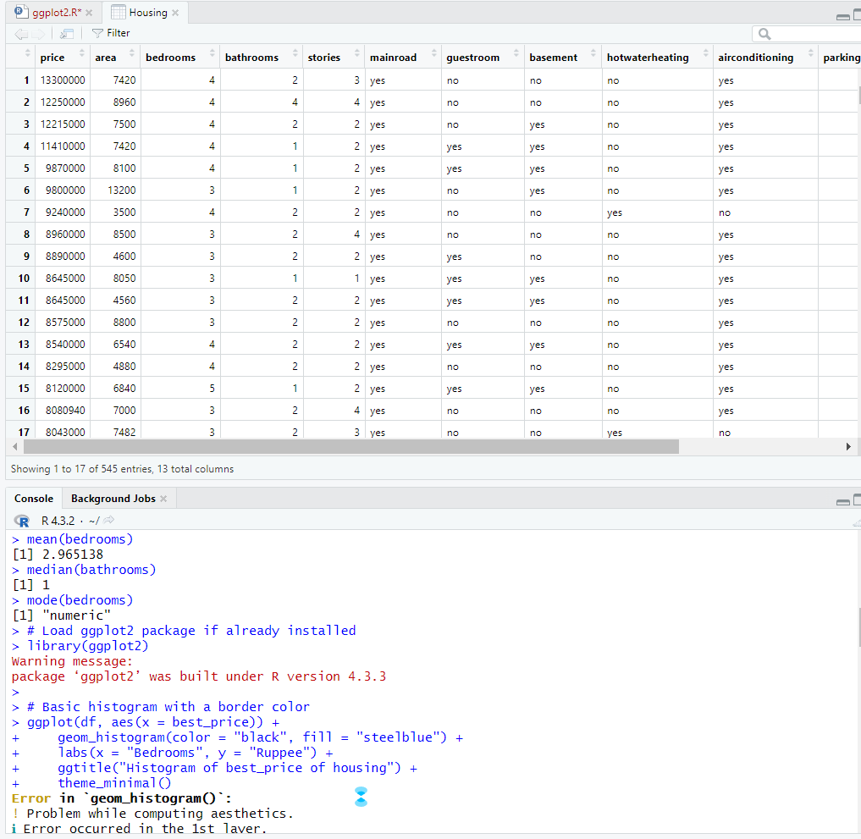

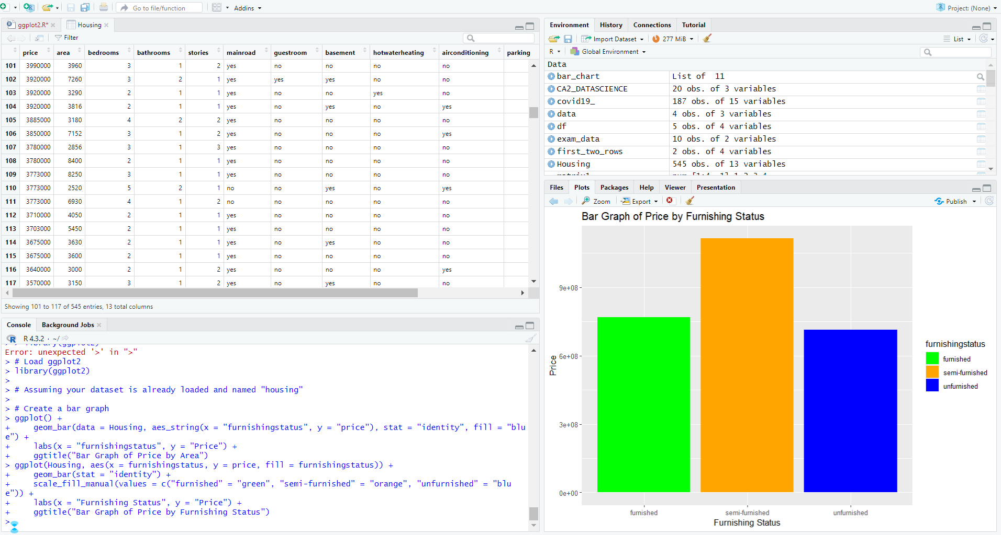

**Conclusion-** I have done descriptive analysis on

1.mean

2 median

3. mode

The bar graph illustrates the price distribution across different furnishing statuses: furnished, semi-furnished, and unfurnished. We can observe that:

Furnished properties tend to have higher prices.

Semi-furnished properties fall in the mid-price range.

Unfurnished properties generally have lower prices.